Git is a version control system.

Git helps you keep track of code changes.

Git is used to collaborate on code.

Git –version

Git and GitHub are different things.

In this tutorial you will understand what Git is and how to use it on the remote repository platforms, like GitHub.

Github

BitBucket

GitLab

t is used for:

* Tracking code changes
* Tracking who made changes
* Coding collaboration

What does Git do?

* Manage projects with **Repositories**
* **Clone** a project to work on a local copy
* Control and track changes with **Staging** and **Committing**
* **Branch** and **Merge** to allow for work on different parts and versions of a project
* **Pull** the latest version of the project to a local copy
* **Push** local updates to the main project
* Git is not the same as GitHub.
* GitHub makes tools that use Git.
* GitHub is the largest host of source code in the world, and has been owned by Microsoft since 2018.

Create account in github and create a repository

Download the git and install it …open command prompt and check

git

Git –version

How to get the file from git repository to the local repository

Open the terminal in the vscode

Git clone

Copy the link of ur repository

Cd ur foldername

---go to the git local repository there u can go to view and show the hidden files

* + U can view .git folder 🡪this act as a bridge between the local and github repository

--next task is to upload the test file from local to github

--once u create a file in vscode ---U -unmodified it shows

Git status

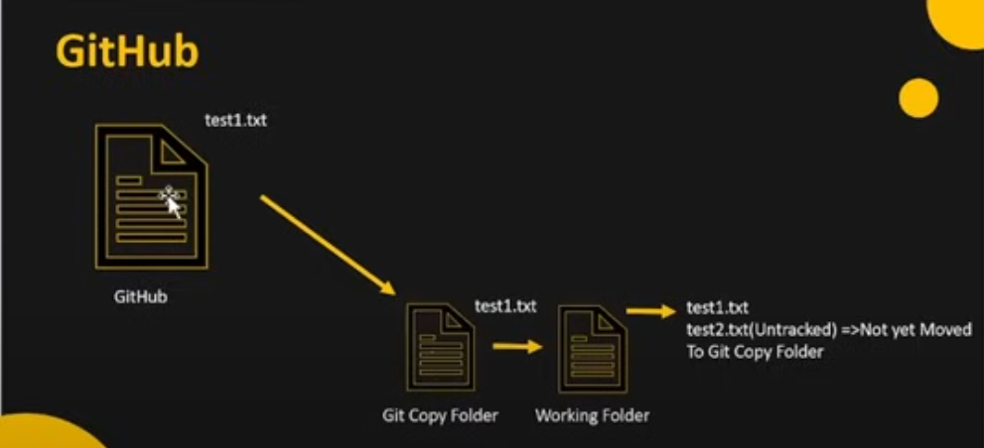

Git add test1.txt

U changed to A

----git add test1.txt

--git commit -m “test1.txt added”

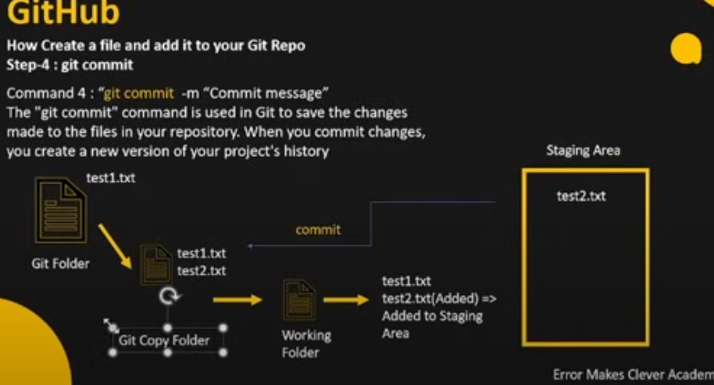

Now from staging area to git copy folder after commit has done

Now need to move the file from git copy folder to github

Git push origin main

--now file moved to git copy folder to github

Insert – add ---commit---push

Now delete one file from local –it will not reflect in the repo

Git add test2.txt

Git commit -m “file deleted”

Git push origin main

Create a file in github repository now pull the file to the local

Git pull

---we don’t need to use clone because we don’t need to get the entire repository

Any modification------add—commit---pull

Now create folder in the local repo and create a index.html file in it

Move back the folder cd..

Cd newfoldername

Git init

Git add .

Git commit -m “add both files”

Git push origin main ----but here its not possible

So create a repository in github and connect using the below command

git remote add origin <https://github.com/RemyaAravind/Gitting.git>

git branch –it shows master

git branch -M main

git push origin main

git branch -a –list all branches

create a new branch in git repository

git checkout newbranch ---this command helps to move from main branch to new branch

now create a file and do the add,commit and push

git push origin newbranch

to know the difference between two branches

---switch to main branch

Git checkout main

Git diff newbranch

Going to merge new branch with the main branch

Git merge newbranch

Git push origin main

Create a new branch

Git branch newbranches

Git push newbranches---it reflect now in github

Pull request ---we don’t have the right to access the main

----create pull request from newfolder

----from the main do the pul request and merge it

Conflict --when both try to change the same file at the same time

---create a new repository –mergeconflic

----create 2 branches –branch1 ,branch2

-----create a file test.txt –give the content city:None

-----now go the branch 1 change the content city:Banglore

-----braanch2 has the content city:Chennai

---now pull request and merge main and branch1

Now when trying to merge branch2 with main ,conflict occurs

----so manually correct the content and merge it with the main